**1.OPEN AEM**

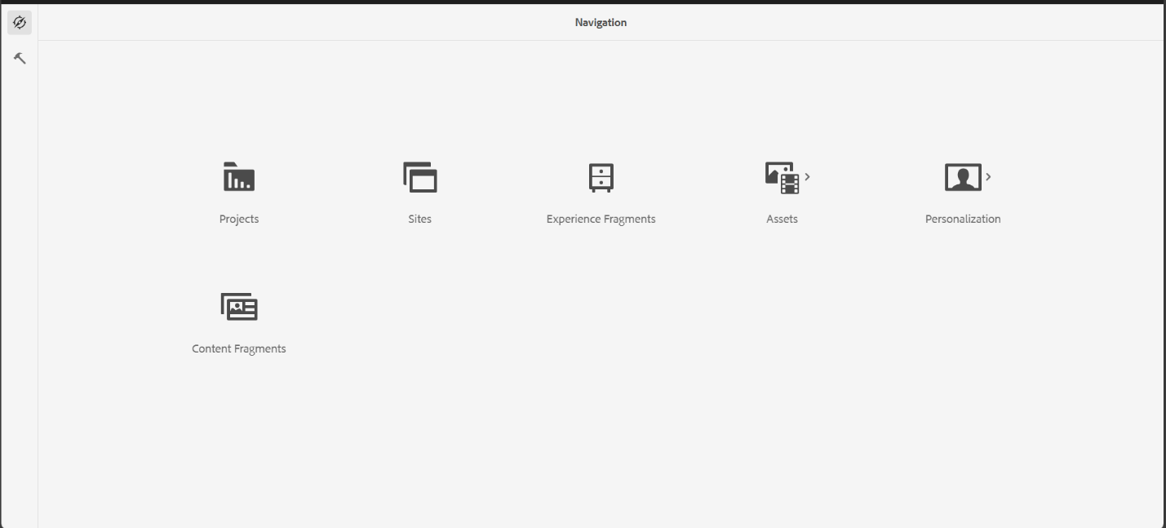

**2.INSIDE TOOLS🡪 TEMPLATES**

**Select book template and click edit**

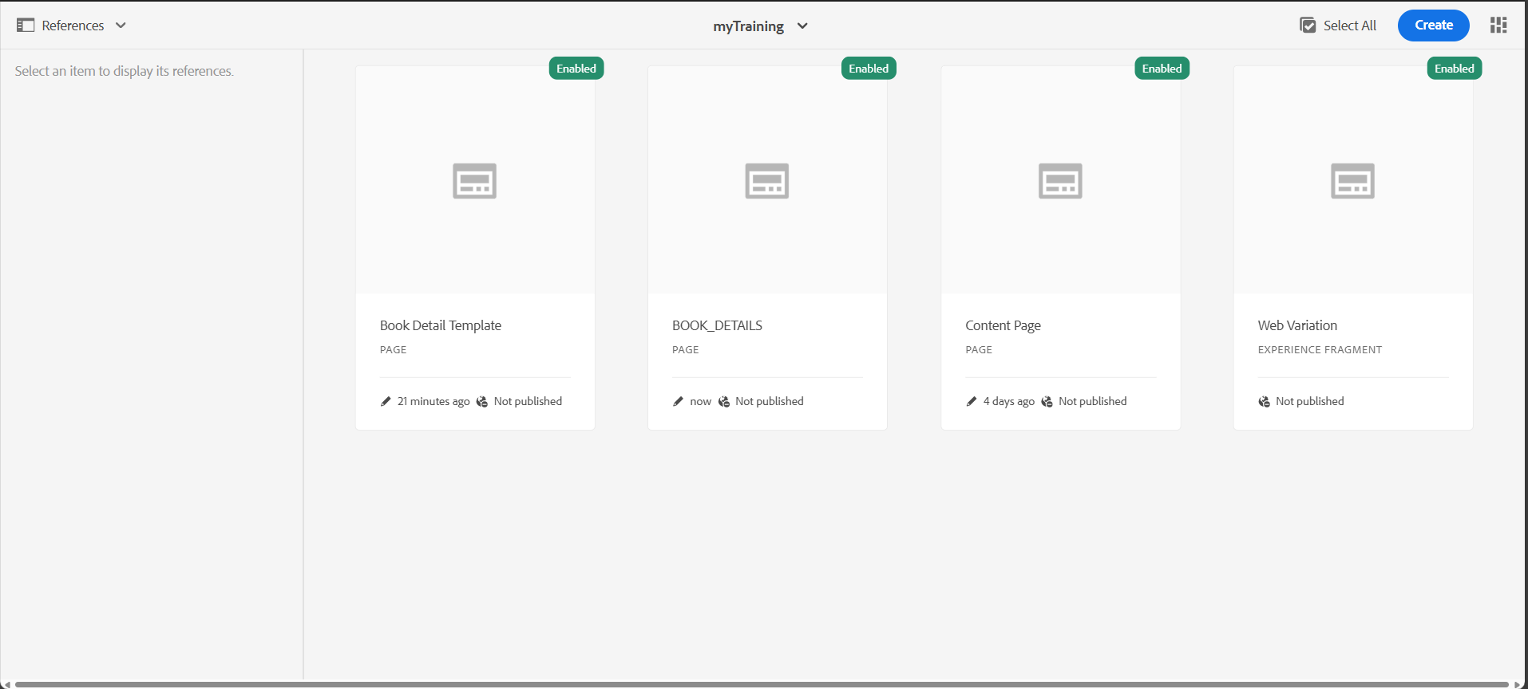

**3.Inside eclipse open myTraining project folder**

**myTraining-> UI.FRONTEND ->SRC -> MAIN -> COMPONENTS -> create file header.scss and footer.scss**

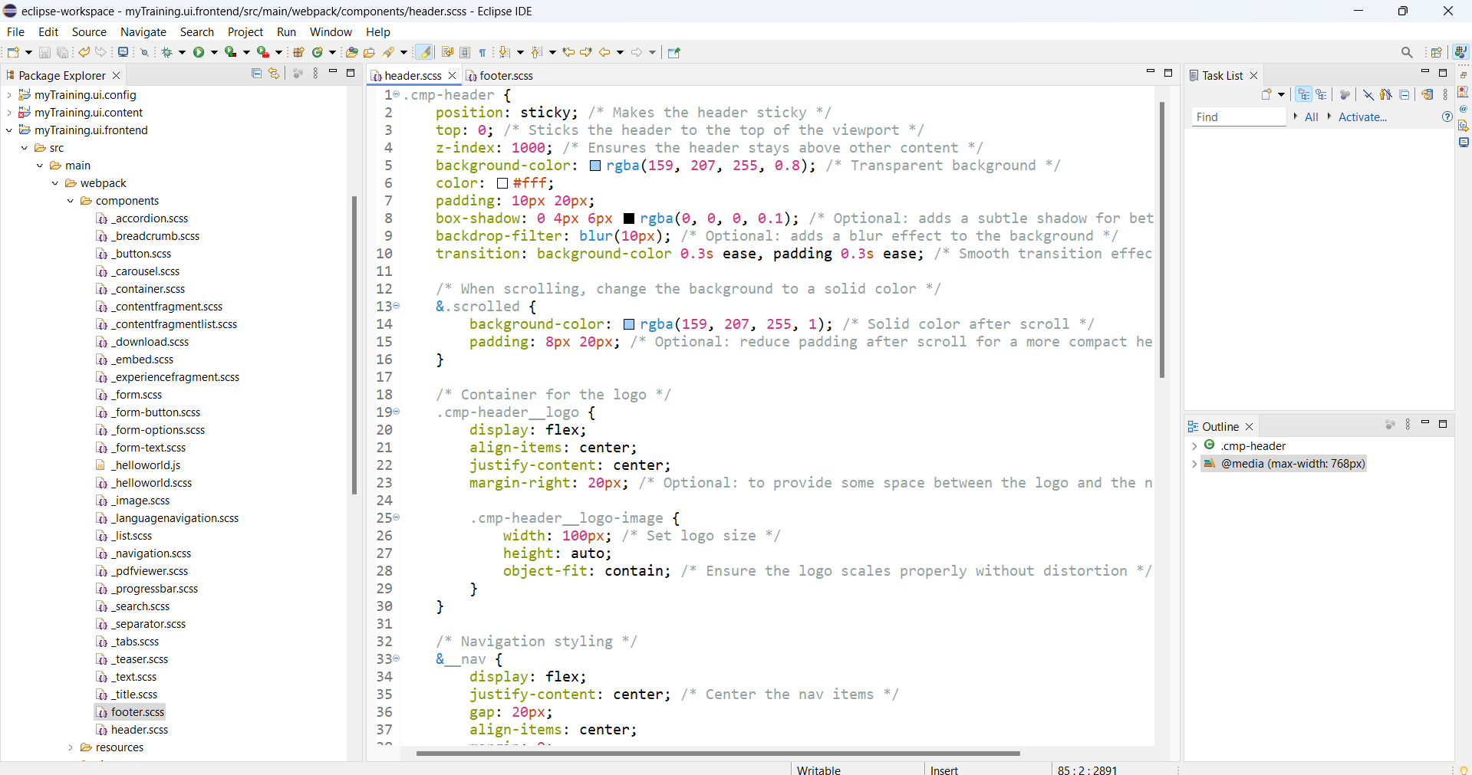

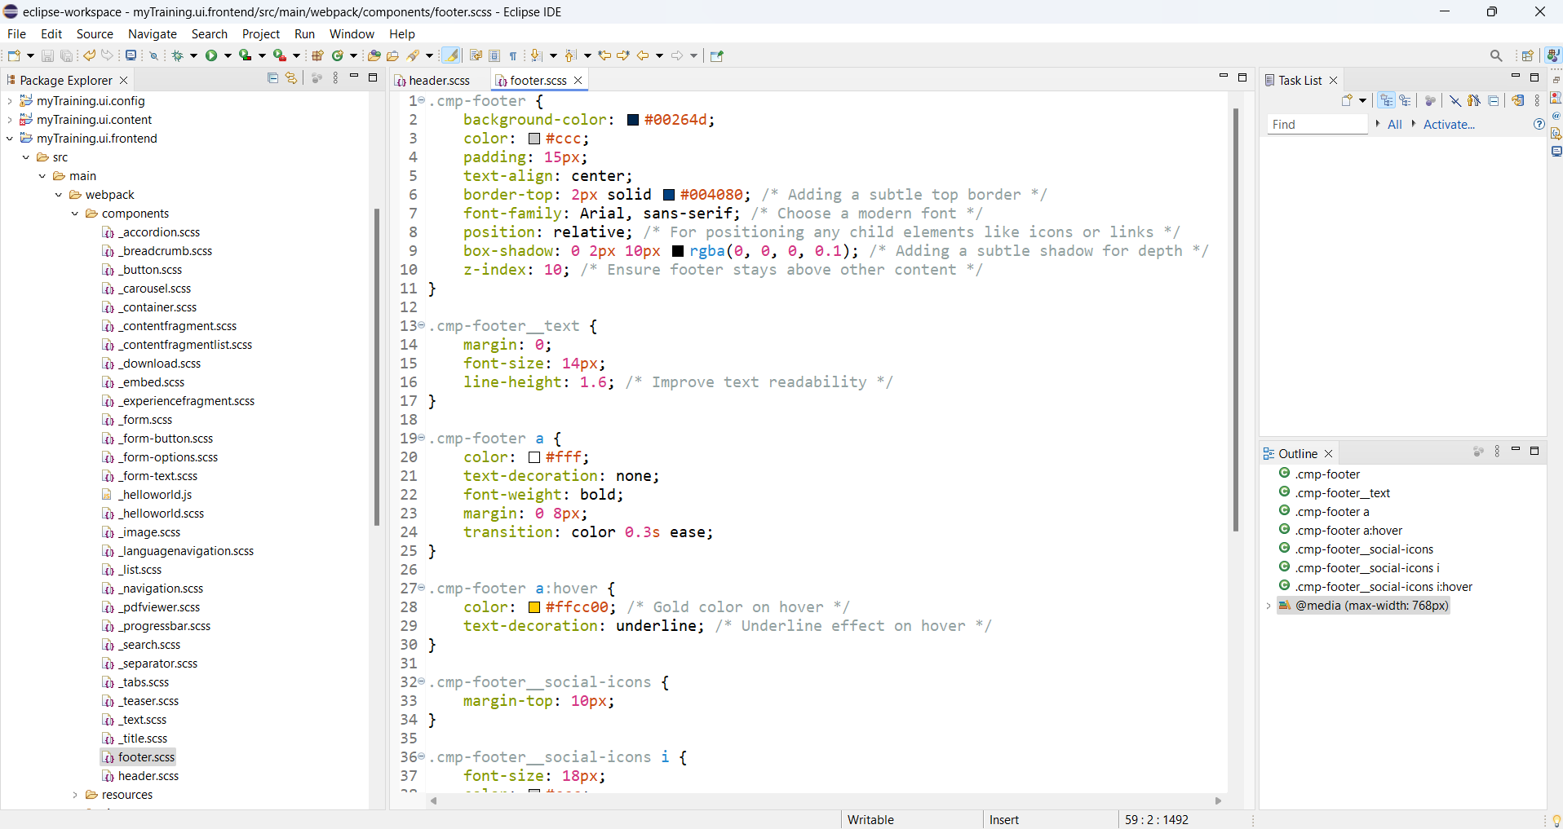**4.Add Experience fragments (Header,Footer)to the book template**

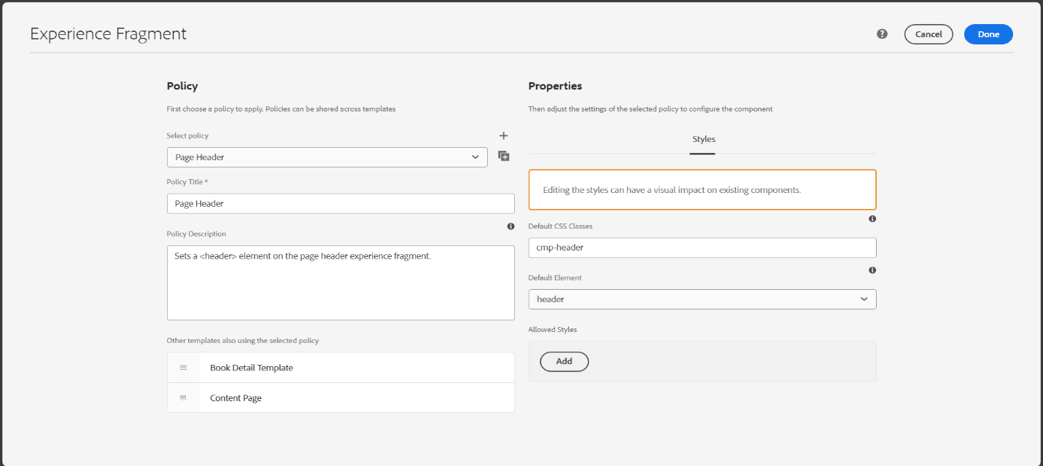

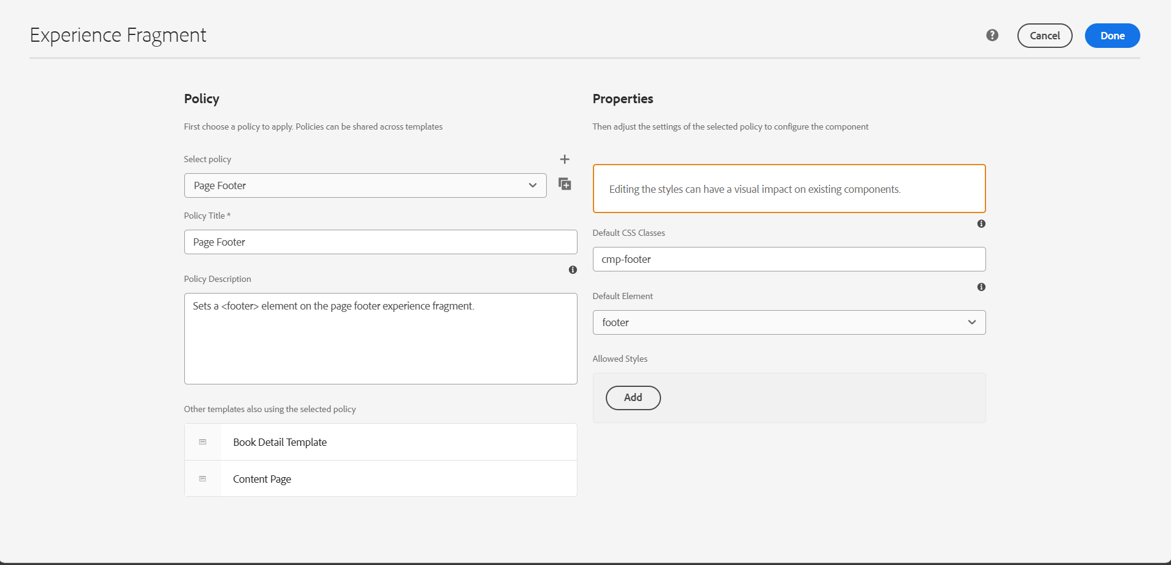

5.Run the project using the command **mvn clean install -PautoInstallPackage -Dmaven.test.skip=true**

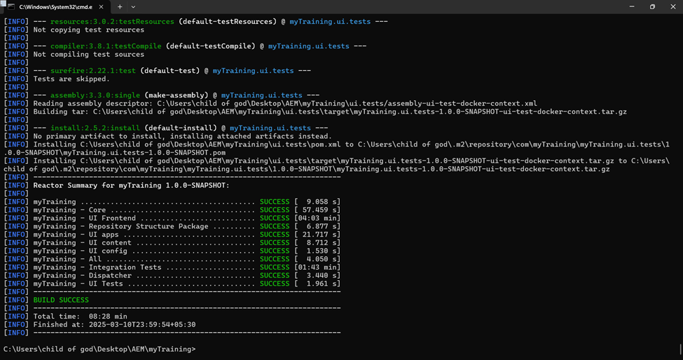

**6.Output:**

